**“WHAT SHOULD YOU WEAR IN YOUR NEXT**

**DATE NIGHT”**

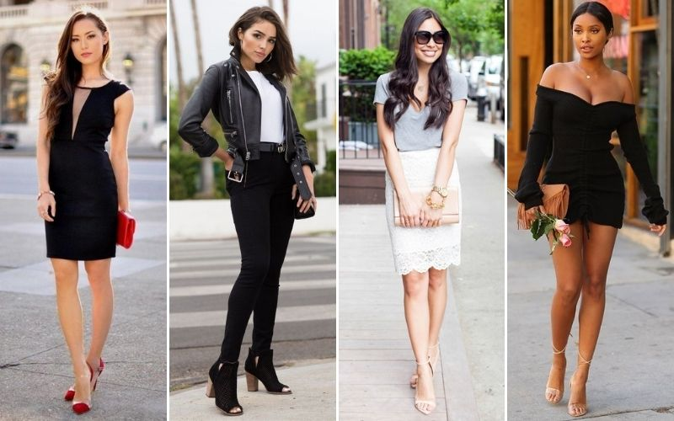

You feel underdressed when you leave the house without simple earrings, and you're in tune with the classics. There are those who say this jewelry style is minimalist, but the classics are that for a reason - they'll always be in fashion. A delicate pendant on your neck, a gold band around a finger – that’s timeless, that’s you!

Take the quiz to find out what jewelry you should be wearing based on your fashion style and personality !

Take quiz

0

1. What hair style you mostly prefer ?
   * 1. Bun or pony tail (1)
     2. Long, Loose Waves (2)
     3. Sleek and Stick Straight (3)
     4. Wavy Bob (4)
2. What dress you most likely to wear?
   1. Think jeans, comfortable T-shirts(1)
   2. Feminine or full dress (2)
   3. Colourful or with prints (3)
   4. Sexy low blouses/dress (4)

1. What would be your choice of footwear?
2. Sneakers
3. Sandals
4. Boots
5. Heels
6. How do you prefer your nails could be ?
7. I don’t like my nails to be coloured
8. Soft pink / nail colours
9. Vibrant colors that stands out
10. Hot pink / red colors to make me feel sexy
11. Lipstick shade that you would most likely to wear ?
12. Color that flatters my dress
13. Nude / soft pink shades
14. Colourful vibrant shades
15. Red
16. Makeup you prefer the most ?
17. No makeup makeup look
18. Light and basic look
19. Colourful eye makeup
20. Full glam

7)What quality do you expect in a date?

1. Humour and fun
2. Caring
3. Confidence
4. Intimidating and masculine appearance

8)Which place would you prefer for date night?

### a) Any comfort Street side restaurant

### b) High end restaurant with candles

### c) Any Restaurant with yummy foods

### d)  Dinner in the dark romantic restaurants.

9)How do you wanna spend date night?

1. Movie
2. Casual talk to know about each other
3. Visit art gallery
4. Go dancing

10)What do you most likely to notice from/in your date ?

a) How he treats the waiter matters to me

b) The way he talks and smiles

c) I check if he asks me of my interest and let me talk about my interests.

d) I most likely to wait for appreciation/ compliments.

1. Casual(street wear, sporty) (mostly a)

Your results show that you are a “Casual basic person” who gives importance to character and personality of a person and also you are someone who most likely to pull off street wear to sporty outfits.

Wearing a right jewelry not only enhances your overall look but also boosts your confidence which will most likely impress your date.

Here are some of the jewelry we suggest based on your personality and interest .

(images)

Necklace (r1.jpg) : https://kmaejewelry.com/collections/necklace/products/april

1. Classic , romantic (mostly b)

Your results show that you are a “Classic, Romantic and a feminine person” who gives importance to emotions, equality and protectiveness and also you are someone who most likely to pull off any classic outfits from formal blazers to prom dresses.

Wearing a right jewelry not only enhances your overall look but also boosts your confidence which will most likely impress your date.

Here are some of the jewelry we suggest based on your personality and interest .

(images)

Necklace(r2.jpg): https://kmaejewelry.com/collections/necklace/products/jenna

1. Vibrant , artsy (mostly c)

Your results show that you are a “Colourful and artsy person” who gives importance to vulnerability and awareness of a person and also you are someone who most likely to pull off any colourful and vibrant outfits.

Wearing a right jewelry not only enhances your overall look but also boosts your confidence which will most likely impress your date.

Here are some of the jewelry we suggest based on your personality and interest .

(images)

Necklace (r3.jpg) : https://kmaejewelry.com/collections/necklace/products/valerie

1. Sexy , edgy (mostly d)

Your results show that you are a “Sexy and maybe a little edgy person” who gives importance to Chemistry and curiosity of a person. You are usually bold and have high confidence and also you are someone who most likely to pull off sexy dresses , low neck blouses and more revealing outfits.

Wearing a right jewelry not only enhances your overall look but also boosts your confidence which will most likely impress your date.

Here are some of the jewelry we suggest based on your personality and interest .

(images)

Necklace(r4.jpg) : <https://kmaejewelry.com/collections/necklace/products/lexi>

Ring(r14.jpg):

<https://kmaejewelry.com/collections/ring>

<https://kmaejewelry.com/collections/bracelet>

<https://kmaejewelry.com/collections/hand-jewelry>

<https://kmaejewelry.com/collections/anklet>

<https://kmaejewelry.com/collections/foot-jewelry>

https://kmaejewelry.com/collections/earring